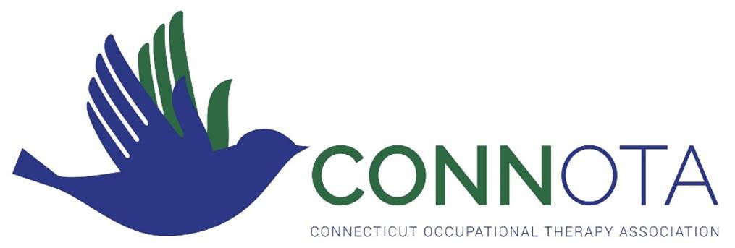

Past ConnOTA Award Winners

2022 Award Winners
- Award of Clinical Excellence
Beth Sullivan, OTR/L
- Award of Service
No Award
- Emerging Leader
Anne Graikoski, OTR/L
- Fieldwork Educator of the Year
Lou Elmo, OTR/L
- President’s Award
Maggie Moriarty, MS, COTA/L

2021 Award Winners
- Award of Merit
Joyce Rioux, EdD, OTR/L, SCSS, FAOTA
- Award of Clinical Excellence
Moira Ethier
- Award of Service
Kristen Downer, OTR/L
- Emerging Leader
Kailene Rampone, COTA/L
- Fieldwork Educator of the Year
Meghan Hobold, COTA/L

2020 Award Winners
- Award of Merit
Stephanie Shivers
- Award of Clinical Excellence
Moira Ethier
- Award of Service
Judith Sheehan
- Emerging Leader
Kelly Pestey
- Fieldwork Educator of the Year
Maureen Leyes

2019 Award Winners
2018 Award Winners
- Award of Merit
No award
- Award of Clinical Excellence
Meghan Spielman
- Award of Service
Goesta H. Schlegel
- Emerging Leader
No award
- Fieldwork Educator of the Year
Deb Orris
- Award of Merit:
No award
- Award of Clinical Excellence
Rick Klimowicz
- Award of Service:
Donna Sweeney
- Fieldwork Educator of the Year
Erin Wells
- Emerging Leader Award:
No award

2017 Award Winners
- Award of Merit:
Elaine Adams
- Award of Service:
Sheelah Schlegel
- Fieldwork Educator of the Year
Joanna Perez
- Emerging Leader Award:
Donna Reed-Oliver
Lisa Marie Tarchini

2016 Award Winners
- Award of Merit:
Sharon McCloskey, MBA, OTR/L DipCOT
Joyce Rioux, EdD, OTR/L, SCSS
- Award of Service:
Lisa Toussaint, OTR/L
- Fieldwork Educator of the Year
Karen Crainich, OTR/L

2015 Award Winner Bios
- Award of Merit: Lenore Frost, PhD, OTR/L, CHT, FAOTA
- Award of Service:
Sharon McCloskey, MBA, OTR/L, DipCOT
Joyce Rioux, EdD, OTR/L, SCSS
- Emerging Leader: Morgan Villano, MPS/MSPS, OTR/L
- Fieldwork Educator:
- Scholarship Recipient
Michael Dezmin, MOTS
Dawn Lesinksi, OTAS
- President's Award: Judith Sheehan, OTR/L, CFo

2014 Award Winner Bios
- Award of Merit: Kimberly Hartman, PhD, OTR, FAOTA
- Award of Service: Susan Goszewski, MSM, OTR
- Emerging Leader: Stacey McIver, MS, OTR
- Fieldwork Educator: Louis Elmo, MS, OTR
- Scholarship Recipient: Kelly Sasso, BS, MOTS

2013 Award Winner Bios
- Award of Merit: Sal Bondoc, OTD, OTR, BCPR, CHT, FAOTA
- Award of Service: Elaine Adams, OTR
- Emerging Leader: Erin Wells MS, OTR
- Fieldwork Educator: Janice McLeod, OTR

2012 Award Winner Bios
- Award of Merit: Tracy Van Oss, DHSc, MPH, OTR, SCEM, CHES, CAPS
- Award of Service: Kimberly Hartmann, Ph.D., OTR, FAOTA
- Emerging Leader: Mary Beth O’Neill, MOTR
- Fieldwork Educator: John Pagano Ph.D. OTR; Regina Morgan, OTR

2011 Award Winner Bios
- Award of Merit: Judith Oliva Sheehan, OTR/L, CFo
- Award of Service: Heather Miller Kuhanek, MS, OTR/L, FAOTA
- Emerging Leader: Kari Cruanes,MS, OTR/L
- Fieldwork Educator: Anne Golensky, OTR/L

