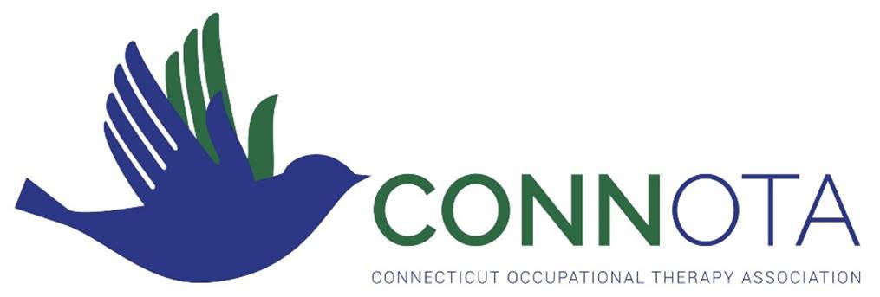
ConnOTA Award Recipients
Award of Merit
Year | Recipient
2009 | Heather Miller Kuhanek, MPH, OTR/L  Tara Glennon, Ed.D OTR/L FAOTA
2010 | Marilyn B. Cole, MS OTR/L FAOTA
2011 | Judith Oliva Sheehan, OTR/L CFo
2012 | Tracy Van Oss, DHSc, MPH, OTR, SCEM, CHES, CAPS
2013 | Sal Bondoc, OTD, OTR, BCPR, CHT, FAOTA
2014 | Kimberly Hartmann, PhD, OTR/L, FAOTA
2015 | Lenore Frost, Ph.D, OTR/L, CHT, FAOTA
2016 | Sharon McCloskey, MBA, OTR/L, DipCOT  Joyce Rioux, Ed.D, OTR/L, SCSS
2017 | Elaine Craddy Adams, MPPA,OTR/L, FAOTA
2018 | No Award
2019 | No Award
2020 | Stephanie Shivers M.Ed., OTR/L, CDP

Award of Clinical Excellence
Year | Recipient
2018 | Rick Klimowicz, MDiv,MHS,OTR/L
2019 | Meghan Spielman, COTA/L
2020 | Moira Ethier, MSGRW, OTR/L
2021 | Joyce Rioux, EdD, OTR/L, SCSS, FAOTA
2022 | Beth Sullivan-Well, OTR/L
2024
2025
2026
2027
2028
2029
2030

Award of Service
Year | Recipient
2009 | Jean Festa, MPH, OTR/L  Irene Herden, MBA, OTR/L, FAOTA
2010 | Judy Sehnal, MS, OTR/L, CPE, FAOTA  Jan Edmondson, MS, OTR/L
2011 | Heather Miller Kuhaneck, MS, OTR/L, FAOTA
2012 | Kimberly Hartmann, Ph.D., OTR, FAOTA
2013 | Elaine Craddy Adams, OTR
2014 | Susan Goszewski, MSM, OTR/L
2015 | Sharon McCloskey, MBA, OTR/L, DipCOT  Joyce Rioux, Ed.D, OTR/L, SCSS
2016 | Lisa Touissaint,OTR/L
2017 | Sheelagh Schlegel, MPH, OTR/L
2018 | Donna Sweeney, M.ED., OTR/L
2019 | Goesta H. Schlegel, MPS, OT/L
2020 | Judith Sheehan, OTR/L, CFo
2021 | Kristen Downer, OTR/L
2022 | No Award

Emerging Leader
Year | Recipient
2009 | Jaclyn Cmero, MS, OTR/L
2010 | Nicole Sawyer, BSHS, MOTS
2011 | Kari Cruanes, MS, OTR/L
2012 | Mary Beth O’Neill, MOTR
2013 | Erin Wells, MS OTR
2014 | Stacey McIvor, MS, OTR/L
2015 | Morgan Villano, MPS/MSPS, OTR/L
2016 | No Award
2017 | Donna Reed Oliver, OTR/L  Lisa Marie Tarchini, COTA/L
2018 | No Award
2019 | No Award
2020 | Kelly Pestey, OSTAS
2021 | Kailene Rampone, COTA/L
2022 | Anne Graikoski, OTR/L

Fieldwork Educator of the Year
Year | Recipient
2009 | Carol Burns, COTA/L
2010 | Pamela Hewett, OTR/L, CAPS
2011 | Anne Golensky, OTR/L
2012 | John Pagano Ph.D., OTR/L  Regina Morgan, OTR/L
2013 | Janice McLeod, OTR/L
2014 | Louis Elmo, MS, OTR/L
2015 | Karen Majeski, OTR/L
2016 | Karen Crainich, OTR/L
2017 | Joanna Perez, OTR/L
2018 | Erin Wells, MS OTR
2019 | Deb Orris, COTA/Lo
2020 | Maureen Leyes, M.Ed., COTA/L
2021 | Meghan Hobold, COTA/L
2022 | Lou Elmo, OTR/L

President’s Award
Year | Recipient
2015 | Judith Sheehan
2017 | Valnere McLean
2018 | Valerie Strange
2019 | No Award
2020 | Amy Burton, OTD, OTR/L
2021 | No Award
2022 | Maggie Moriarty, MS, COTA/L

